**AGILE MODEL**

**What is an Agile Model?**

The Agile Model is an incremental and iterative process of software development. It defines each iteration’s number, duration, and scope in advance. Every iteration is considered a short “frame” in the Agile process model, which mostly lasts from two to four weeks.

Agile Model divides tasks into time boxes to provide specific functionality for the release. Each build is incremental in terms of functionality, with the final build containing all the attributes. The division of the entire project into small parts helps minimize the project risk and the overall project delivery time.

**Here is the essential manifesto of the Agile Model:**

* Individuals and interactions are given priority over processes and tools.
* Adaptive, empowered, self-organizing team.
* Focuses on working software rather than comprehensive documentation.
* Agile Model in software engineering aims to deliver complete customer satisfaction by rapidly delivering valuable software.
* Welcome changes in requirements, even late in the development phase.
* Daily co-operation between businesspeople and developers.
* Priority is customer collaboration over contract negotiation.
* It enables you to satisfy customers through early and frequent delivery.
* A strong emphasis is placed on face-to-face communication.
* Developing working software is the primary indicator of progress.
* Promote sustainable development pace.
* A continuous focus is placed on technical excellence and sound design.
* An improvement review is conducted regularly by the team.

**Phases of Agile Model**

Here are the different phases of Agile:

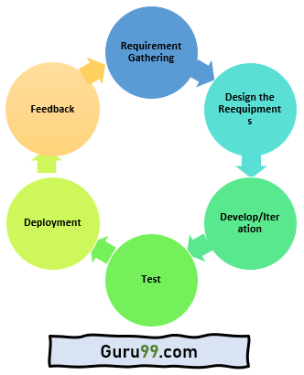

Here are the important stages involved in the Agile Model process in the SDLC life cycle:

* **Requirements Gathering:**

 In this Agile model phase, you must define the requirements. The business opportunities and the time and effort required for the project should also be discussed. By analyzing this information, you can determine a system’s economic and technical feasibility.

* **Design the Requirements:**

Following the feasibility study, you can work with stakeholders to define requirements. Using the UFD diagram or high-level UML diagram, you can determine how the new system will be incorporated into your existing software system.

* **Develop/Iteration:**

The real work begins at this stage after the software development team defines and designs the requirements. Product, design, and development teams start working, and the product will undergo different stages of improvement using simple and minimal functionality.

* **Test:**

 This phase of the Agile Model involves the testing team. For example, the Quality Assurance team checks the system’s performance and reports bugs during this phase.

* **Deployment:**

In this phase, the initial product is released to the user.

* **Feedback:**

 After releasing the product, the last step of the Agile Model is feedback. In this phase, the team receives feedback about the product and works on correcting bugs based on the received feedback.

**Types of Agile**

**Scrum:**

This agile method focuses primarily on managing tasks in team-based development conditions. In the[Scrum Agile model](https://www.guru99.com/agile-scrum-extreme-testing.html#scrum), the team should strictly follow a work plan for each Sprint. Moreover, people involved in this type of project have predefined roles.

**Crystal:**

Using Crystal methodology is one of the most straightforward and most flexible approaches to developing software, recognizing that each project has unique characteristics. Therefore, policies and practices need to be tailored to suit them.

Crystal methodologies are categorized as below:

* **CLEAR:**User for small and low critical efforts.
* **ORANGE:**User for moderately larger and critical projects.
* **ORANGE WEB:**Typically, electronic business

**Dynamic Software Development Method (DSDM)**:

This Rapid Application Development (RAD) approach involves active user involvement, and the teams are empowered to make decisions with the goal of frequent product delivery.

**Feature Driven Development (FDD):**

This Agile method focuses on “designing & building” features. It is divided into several short phases of work that must be completed for each feature separately. It includes domain walkthrough, design inspection, code inspection, etc.

**Lean Software Development:**

This methodology is based on the principle of “Just-In-Time Production.” It helps to increase the speed of software development and decrease costs.

As a result of a lean development model, waste is eliminated, learning is amplified, early delivery is achieved, and integrity is built.

**Extreme Programming (XP):**

[Extreme Programming](https://www.guru99.com/agile-scrum-extreme-testing.html#extreme-programming) is a useful Agile model when there are constantly changing requirements or demands from clients. It is also used when there is no sure about the system’s functionality.

**Advantages of the Agile Model**

* Communication with clients is on a one-on-one basis.
* Provides a very realistic approach to software development
* Updated versions of functioning software are released every week.
* It delivers early partial working solutions.
* Changes are acceptable at any time.
* The final product is developed and available for use within a few weeks.

**Disadvantages of Agile Model**

* There is a higher risk of sustainability, maintainability, and extensibility.
* In some corporations, self-organization and intensive collaboration may not be compatible with their corporate culture.
* Documentation and design are not given much attention.
* Without clear information from the customer, the development team can be misled.
* Not a suitable method for handling complex dependencies.

**AGILE METHODOLOGY:**

**1.Scrum:**

**Scrum** is the type of **Agile framework**. It is a framework within which people can address complex adaptive problem while productivity and creativity of delivering product is at highest possible values. Scrum uses Iterative process. Silent features of Scrum are:

* ScrumMaster
* Product Owner
* ScrumTeam

**Lifecycle of Scrum:**

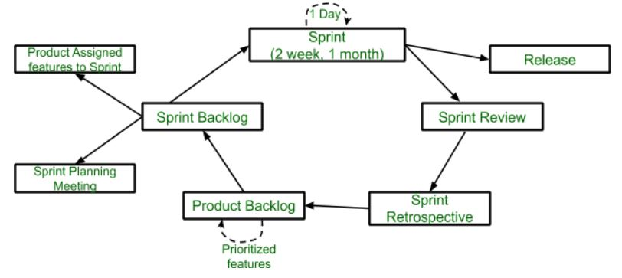

**Sprint:**

 A Sprint is a time box of one month or less. A new Sprint starts immediately after the completion of the previous Sprint.

**Release:**

 When the product is completed, it goes to the Release stage.

**Sprint Review:**

 If the product still has some non-achievable features, it will be checked in this stage and then passed to the Sprint Retrospective stage.

**Sprint Retrospective:**

 In this stage quality or status of the product is checked.

**Product Backlog:**

  According to the prioritize features the product is organized.

**Sprint Backlog:**

 Sprint Backlog is divided into two parts Product assigned features to sprint and Sprint planning meeting.

**Advantage of using Scrum framework:**

1. Scrum framework is fast moving and money efficient.
2. Scrum framework works by dividing the large product into small sub-products. It’s like a divide and conquer strategy
3. In Scrum customer satisfaction is very important.

**Disadvantage of using Scrum framework:**

1. Scrum framework do not allow changes into their sprint.
2. Scrum framework is not fully described model. If you wanna adopt it you need to fill in the framework with your own details like Extreme Programming(XP), Kanban, DSDM.
3. It can be difficult for the Scrum to plan, structure and organize a project that lacks a clear definition.
4. The daily Scrum meetings and frequent reviews require substantial resources.

**2.Crystal:**

The crystal method is an agile framework that is considered a lightweight or agile methodology that focuses on individuals and their interactions. The methods are color-coded to significant risk to human life. It is mainly for short-term projects by a team of developers working out of a single workspace. Among a few Agile [Software Development Life Cycle (SDLC)](https://www.geeksforgeeks.org/software-development-life-cycle-sdlc/) models crystal is considered as one of the Agile SDLC models.

Two core beliefs of the Crystal method:

* Find your own way and methods to optimize workflow.
* Make use of unique methods to make the project unique and dynamic.

The below figure illustrates about crystal team

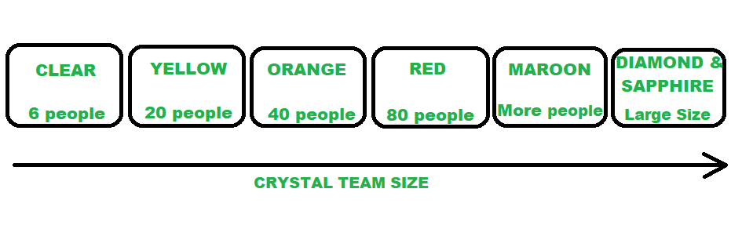

*CRYSTAL FAMILY (TEAM MEMBERS)*

**ADVANTAGES:**

1. Facilitate and enhance team communication and accountability.
2. The adaptive approach lets the team respond well to the demanding requirements.
3. Allows team to work with the one they see as the most effective.
4. Teams talk directly with each other, which reduces management overhead.

**DISADVANTAGES:**

1. A lack of pre-defined plans may lead to confusion and loss of focus.
2. Lack of structure may slow down inexperienced teams.
3. Not clear on how a remote team can share knowledge informally.

**3.Dynamic Systems Development technique (DSDM)** :

The **Dynamic Systems Development technique (DSDM)** is an associate degree agile code development approach that provides a framework for building and maintaining systems. The DSDM philosophy is borrowed from a modified version of the sociologist principle—80 % of An application is often delivered in twenty percent of the time it’d desire deliver the entire (100 percent) application.

**DSDM project involves 7 phases of software development :**

**1.**pre-project

**2.**feasibility study

**3.**business study

**4.**functional model iteration

**5.**design and build iteration

**6.**implementation

7**.**post-project.



**4.LEAN SOFTWARE DEVELOPMENT:**

Lean product development is a process for building products faster with less waste. Lean development forces the teamto ruthlessly remove any activity that does not bring ultimate value to the product.

The goal of lean product development is to improve the overall throughput of the system, sustainably, in ways other than just simply throwing more money and resources into it.

This technique is based on 'just in time production'. The idea is to increase the pace at which a software is being built and reduce cost as a result. Lean development can be categorised into seven parts,

* 1. Eliminate waste
  2. Enhance learning
  3. Early delivery
  4. Empower the team
  5. Build integrity
  6. Optimize the complete process



**Key feature of LSD:**

* Focus on continuous improvement and waste elimination
* Iterative and collaborative approach
* Development of Minimum Viable Product (MVP)
* Customer involvement and feedback
* Flexible and adaptive approach
* Prioritization of essential functions and minimization of waste

**8.EXTREME PROGRAMMING:**

Extreme programming or XP is a method which **serves a useful purpose when customer demands are rapidly changing**. It facilitates frequent releases of the product under development in short development cycles which is helpful in improving the productivity of the system.

Extreme programming generally involves six phases:

1.Planning

2.Analysis

3.Design

4.Execution

5.Wrapping

6.Closure

